SOHAN M 31-05-2022
1NT19IS155

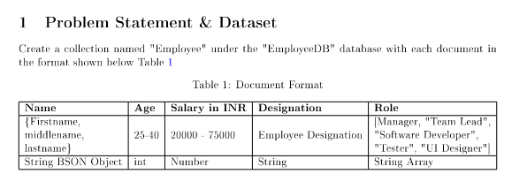

2 Queries

1. Populate the database with atleast 15 documents

db.employee155.find()
{ "_id" : ObjectId("629594062787f6be58c1dc7c"), "firstname" : "Sohan", "lastname" : "M", "age" : 21, "salary" : 80000, "designation" : "Manager", "role" : [ "Manager", "Team Lead" ] }

{ "_id" : ObjectId("629594062787f6be58c1dc7d"), "firstname" : "Rajesh", "lastname" : "kutharpalli", "age" : 22, "salary" : 68500, "designation" : "Employee", "role" : [ "Assistant" ] }

{ "_id" : ObjectId("629594062787f6be58c1dc7e"), "firstname" : "Pratheek", "lastname" : "kumar", "age" : 20, "salary" : 60000, "designation" : "Employee", "role" : [ "Tester", "UI designer" ] }

{ "_id" : ObjectId("629594062787f6be58c1dc7f"), "firstname" : "Praneeth", "lastname" : "Kumar", "age" : 20, "salary" : 70000, "designation" : "HR", "role" : [ "Team Lead" ] }

{ "_id" : ObjectId("629594062787f6be58c1dc80"), "firstname" : "Shriman", "lastname" : "M", "age" : 22, "salary" : 40000, "designation" : "Employee", "role" : [ "Software Developer", "Tester" ] }

{ "_id" : ObjectId("629594062787f6be58c1dc81"), "firstname" : "Rajesh", "lastname" : "kumar", "age" : 26, "salary" : 200000, "designation" : "Scientist", "role" : [ "UI designer" ] }
{ "_id" : ObjectId("629594062787f6be58c1dc82"), "firstname" : "Vishal", "lastname" : "Hk", "age" : 20, "salary" : 55650, "designation" : "Software Developer", "role" : [ "Team Lead" ] }

{ "_id" : ObjectId("629594062787f6be58c1dc83"), "firstname" : "Madhu", "lastname" : "kumar", "age" : 38, "salary" : 50000, "designation" : "Software Developer", "role" : [ "Tester" ] }

{ "_id" : ObjectId("629594d32787f6be58c1dc84"), "firstname" : "Ullaas", "lastname" : "s", "age" : 18, "salary" : 5000, "designation" : "Employee", "role" : [ "Tester" ] }

{ "_id" : ObjectId("629595072787f6be58c1dc85"), "firstname" : "Rakshit", "lastname" : "kumar", "age" : 40, "salary" : 95000, "designation" : "Employee", "role" : [ "Manager" ] }

{ "_id" : ObjectId("6295953f2787f6be58c1dc86"), "firstname" : "Laisha", "lastname" : "S", "age" : 45, "salary" : 65000, "designation" : "Employee", "role" : [ "Manager" ] }

{ "_id" : ObjectId("629595692787f6be58c1dc87"), "firstname" : "Sai Surya", "lastname" : "S", "age" : 25, "salary" : 55650, "designation" : "Employee", "role" : [ "Team Lead" ] }

{ "_id" : ObjectId("629595902787f6be58c1dc88"), "firstname" : "Suraj", "lastname" : "kumar", "age" : 26, "salary" : 5650, "designation" : "Employee", "role" : [ "Tester" ] }

{ "_id" : ObjectId("629596b42787f6be58c1dc89"), "firstname" : "vISTA", "lastname" : "cr", "age" : 26, "salary" : 5650, "designation" : "Employee", "role" : [ "Tester" ] }

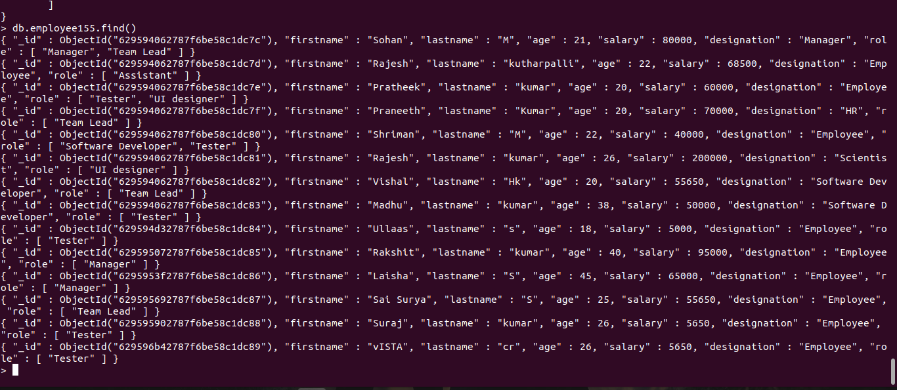

2. List all the records having salary in the range of 20000 - 35000(Exclusive)

db.employee155.find({ $and: [ {salary: {$gte: 20000}} ,{salary: {$lte: 35000}}]}).pretty()
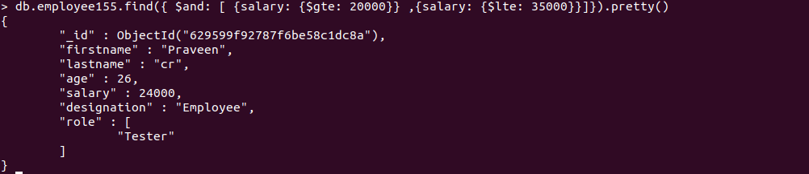

3. List all the Employee whose Middle name is "Kumar"

db.employee155.find({ lastname:"kumar"}).pretty()

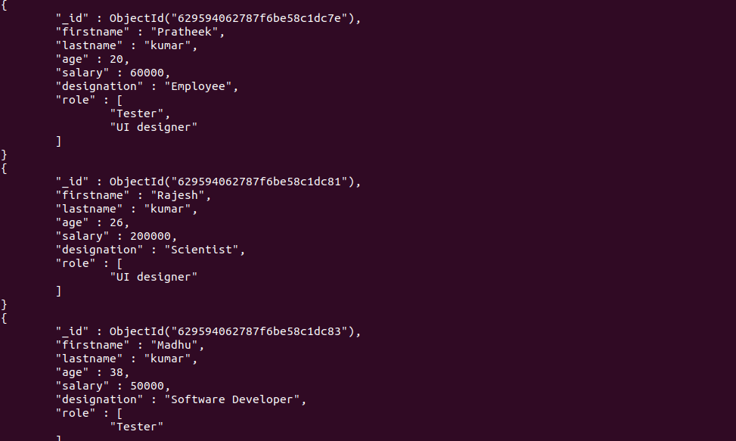

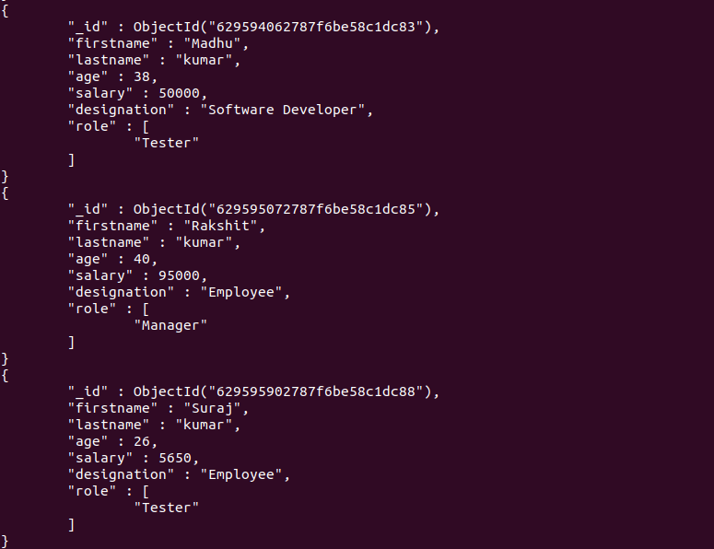

4. Count the number of Employees who has a role "Manager" in the Role field

db.employee155.count({role:"Manager"})

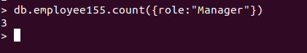

5. Find out all the documents who have age < 35 and salary in the range of 30000-35000

db.employee155.find({ $and: [ {salary: {$gte: 30000}} ,{salary: {$lte: 35000}} ,{age:{$lte:35}}]}).pretty()



6. Delete an Employee whose "Firstname" is "Rajesh" and having the designation as "Scientist"

db.employee155.remove({ $and: [ {firstname: "Rajesh"} ,{designation:"Scientist" }]})

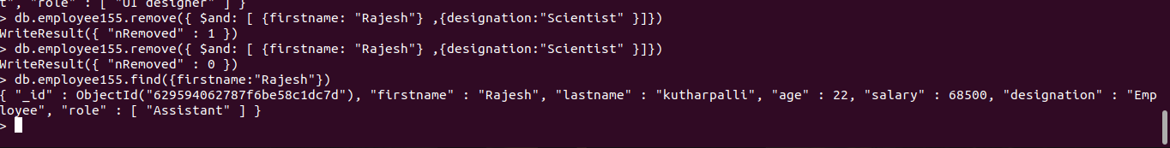

7. Update all the Employees whose role is "Team Lead" with a salary of 55650 INR

db.employee155.updateMany({role: "Team Lead"},{$set : {salary:55650}})

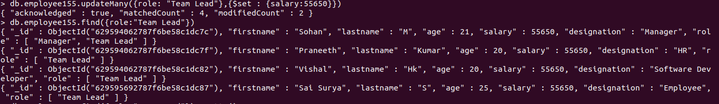

8. Group all the Employees by their age(common age should be there) and calculate the average salary obtained in the each group

db.employee155.aggregate([{$group: {_id: "$age",AVERAGE: {$avg: "$salary"}}}])



9. Apply the map-reduce to perform the above operation and obtain the results

var mapfunction=function(){emit(this.age,this.salary)}
> var reducefunction=function(key,values){return Array.avg(values)}
> db.employee155.mapReduce(mapfunction,reducefunction,{'out':'result'})

